**Little Goose Debris Management**

Forebay:

Little Goose Lock and Dam staff try to manage debris to the best of their ability. Debris management starts in the forebay. Little Goose Dam lost the trash shear boom in 2014 and struggled to manage debris during high flows in subsequent years (Image 1 & 2). The debris boom and boat barrier were installed in the winter of 2017-2018. Unfortunately, the boat barrier caught a large mass of debris and created additional debris issues for the 2018 spring runoff (Image 3). The boat barrier was opened on June 04, 2018 to let debris flow freely through the surface weir. The section of boat barrier located immediately upstream of the surface weir has been permanently removed from service. Additionally, Little Goose is in the process of procuring a large enough work vessel which could be utilized to safely remove debris from the forebay.

Project staff utilize a crane and clamshell style mechanism to remove debris from Unit trash racks. Trash raking has not been the most effective tool to prevent debris from entering the juvenile bypass system. There have been numerous instances that heavy debris loads have been seen in the juvenile bypass system and trash raking was implemented. Minimal debris was collected and debris issues continued within the juvenile bypass system (Image 4). The crane and clamshell are also used to remove floating surface debris in the immediate forebay, but is not very effective. Trash racks are cleaned prior to installing ESBS screens in March and are raked at least monthly during spring runoff. Gatewell slots are dipped for debris prior or during ESBS install to remove debris utilizing a crane and basket. Gatewell slots are then kept clean utilizing grappling hooks and ropes on a daily basis, typically during daytime orifice inspections. Little Goose rarely experiences high amounts of floating debris in the gatewell causing 50% coverage. When debris loads within the gatewell are high, fish facility staff use the crane and basket to remove debris in conjunction with trash raking.

Fish facility staff measure drawdowns in gatewell and bulkhead slots to weekly from April 1–June 30, and biweekly (once every two weeks) for the remainder of the operating season. Fish facility staff also visually inspect VBS’s and ESBS’s utilizing an underwater camera during trash raking and Unit annuals, as turbidity allows.

Little Goose has experimented with debris spills, but has had minimal success. The steel frame connecting the trash shear boom catches the majority of debris (Image 5). When favorable wind conditions arise, Little Goose will shut down Units 1 and 2, operate the adult ladder cooling pump and utilize the trash rack crane and various personnel to guide debris toward the surface weir. This tactic seems to remove the smaller debris which causes the majority of the issues in the juvenile bypass system, but is not effective for removing all debris.

The ESBS’s are kept clean using mechanical brushes which are set on an automatic timer. Brushes are operated every 4 hours during normal operation and every 2 hours during high debris. Fish facility staff operate the brushes manually once per month to ensure proper operation and also check to ensure the trouble light on each electronic cabinet are functioning during each orifice inspection. ESBS operation is also monitored in the control room around the clock via computer alarm annunciation system. Little Goose is also in the process of replacing all vertical barrier screens (Image 6).

Juvenile Bypass System:

Fish facility staff rotate and/or backflush orifices at least three times per 24-hour period. Frequency increases during high runoff and increased debris load. For example, Little Goose JFF currently has an additional person working nights to cover additional orifice checks instead of relying on an operator to check orifices multiple times throughout the night. Remove any debris from orifices using the backflush system or any other means necessary to remove debris blockages. Orifice checks are monitored via datasheet and also in the control room logbook. Operate mechanical brushes and air bubbler system on the primary dewatering structure during daytime orifice checks AND at night when debris is heavy. Ensure the separator tech is on standby during orifice checks and when operating the mechanical brushes at the primary dewatering structure so they can remove debris from the separator immediately.

Juvenile Fish Facility:

Remove debris from the separator immediately as it enters. Sometimes this is a fulltime job and requires additional staff. The separator tech checks separator exits, flumes, raceway headboxes, holding tanks, direct load pipes, diversion gates and counting tunnels during hourly rounds. Monitor barge dock via security camera from the separator to ensure proper water flow through diversion gates and direct load lines. Clean porosity plates and Johnson bar screens during hourly rounds. Remove debris from raceways once fish are loaded into the transportation vessel. If debris loads in raceways are extreme, utilize mechanical crowder to sweep debris to the upper end of the raceway in order to minimize the risk of plugging the raceways release and associated lines. Monitor debris in separator and clean out during season if needed for safe fish passage (Image 7).

All debris is either sent back to the river through the bypass flume or transported to a dump area upstream of the dam.

Image 1: Little Goose Forebay, April 2017.

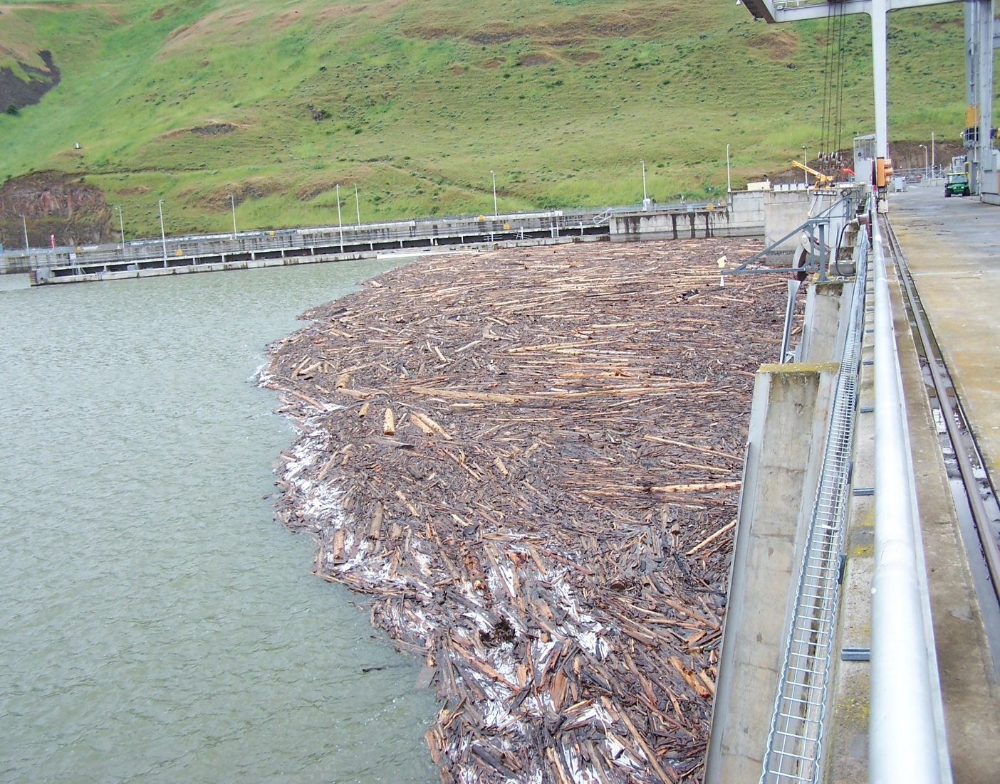

Image 2: Debris collected on Units 1 and 2 during trash raking, April 2017.

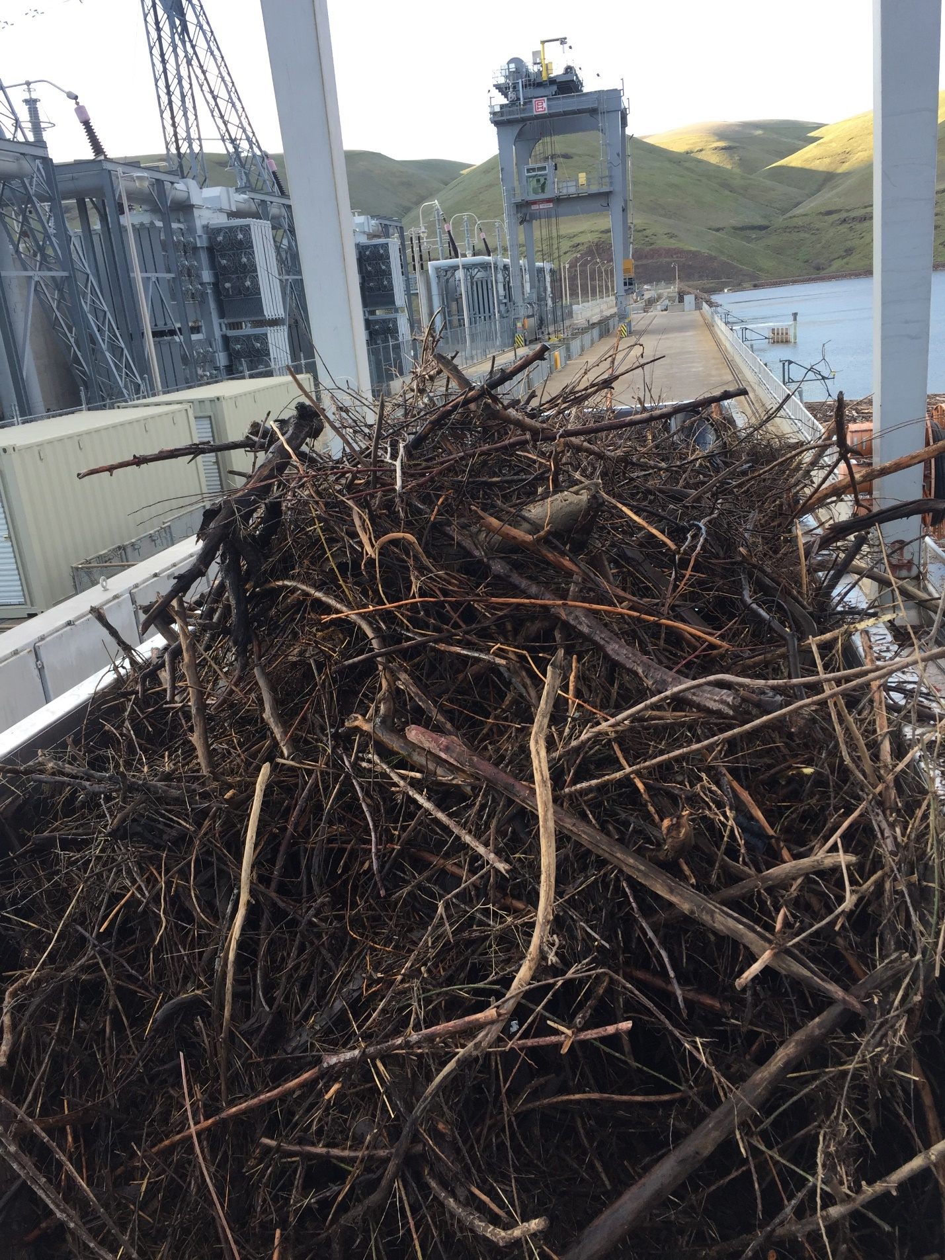

Image 3: Debris collected upstream of boat barrier, 2018.

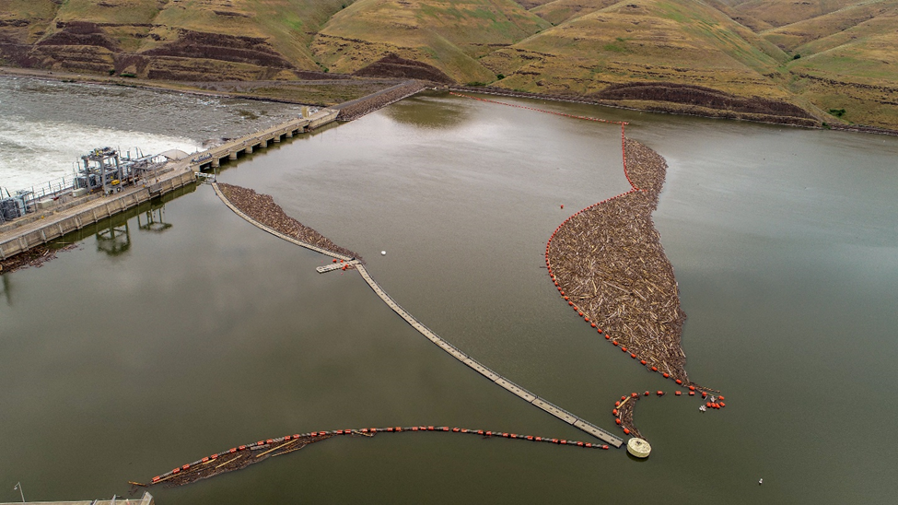

Image 4: Debris collected on all Units during trash raking, May 29, 2018.

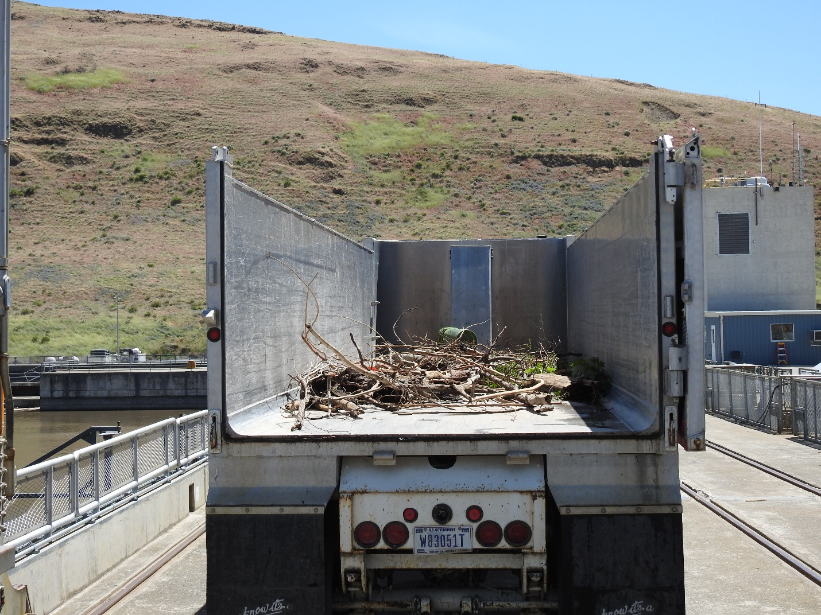

Image 5: Debris caught on trash shear boom frame during attempted debris spill, 2019.

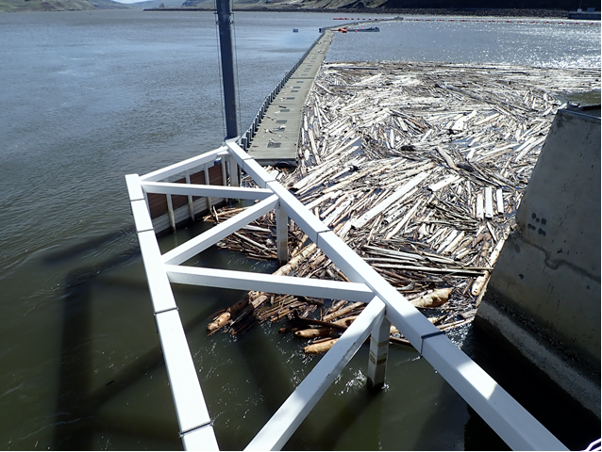

Image 6: Newly installed VBS screen at Little Goose Lock and Dam, 2017.

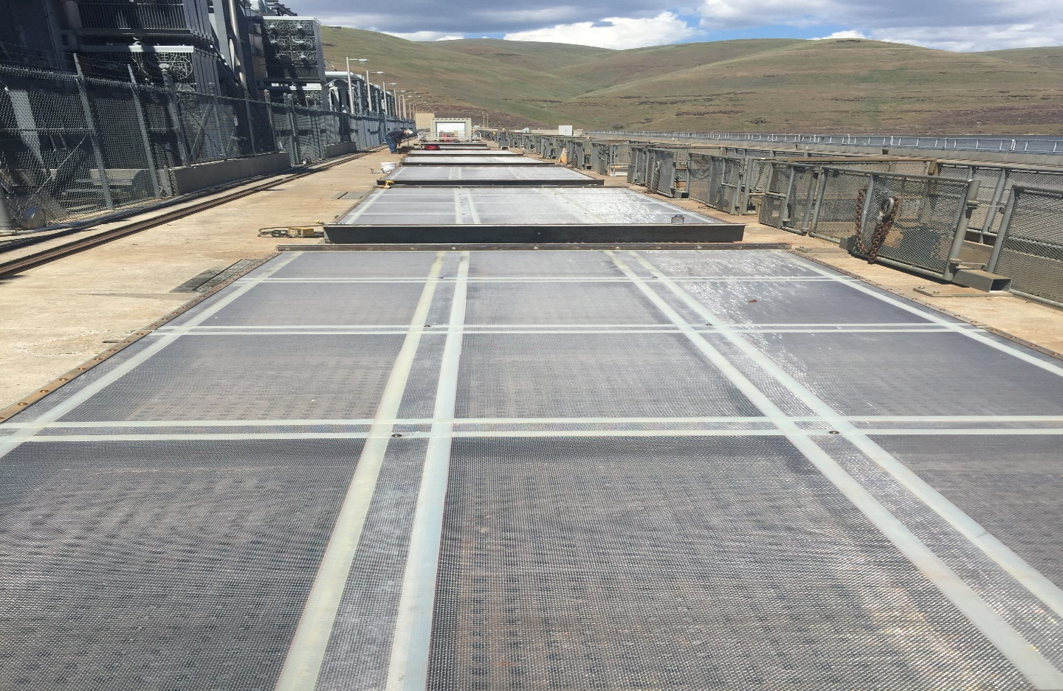

Image 7: Fish facility removing debris from separator, 2017.

